Project Design Phase
Solution Architecture

Date | 29 October 2025
Team ID | NM2025TMID04658
Project Name | Optimizing User, Group, and Role Management with Access Control and Workflows
Maximum Marks | 4 Marks

Solution Architecture:

Goals of the Architecture
- Implement a centralized and secure access control system for managing users, groups, and roles.
- Ensure automated workflow validation during creation, modification, and removal of user permissions.
- Maintain data consistency and prevent unauthorized access or misconfigured role assignments.
- Reduce manual administrative effort through workflow-based automation and dependency checks.
- Enable real-time synchronization of access updates across integrated systems.

Key Components
- User Management Module – Handles creation, modification, and deactivation of user accounts.
- Group and Role Repository – Stores hierarchical role relationships and access policies.
- Access Control Engine (RBAC System) – Enforces permissions and access boundaries dynamically.
- Workflow Automation Module – Manages approval flows for user and role requests.
- Audit and Logging Layer – Captures all access changes, workflow actions, and system events.
- Notification System – Sends real-time alerts to users and administrators on access updates or approvals.

Development Phases
- User and Role Setup – Define sample users, groups, and roles within the system.
- Workflow Creation – Configure approval workflows for adding, updating, or revoking access.
- Access Control Implementation – Apply Role-Based Access Control (RBAC) logic with dependency checks.
- Integration and Testing – Test all modules by simulating access requests, approval flows, and conflict scenarios.
- Validation and Monitoring – Ensure the system maintains security, compliance, and accurate access tracking.
- Solution Architecture Description
The solution architecture is designed to optimize and automate the entire lifecycle of user, group, and role management.
It integrates workflow automation with access control logic to ensure secure and compliant operations within enterprise systems.
Whenever a user is added or modified, the system automatically checks their group and role dependencies before applying access permissions. A workflow approval process is triggered for any access change, ensuring that only authorized managers can approve modifications.
The Access Control Engine validates every transaction using Role-Based Access Control (RBAC) principles, preventing redundant or conflicting permissions.
Each action—whether it’s role assignment, access update, or user deactivation—is recorded in an audit log for transparency and traceability.
This architecture reduces administrative workload, enhances organizational security, and ensures consistency across departments. It provides an end-to-end automated framework for managing access with high reliability, scalability, and accountability.

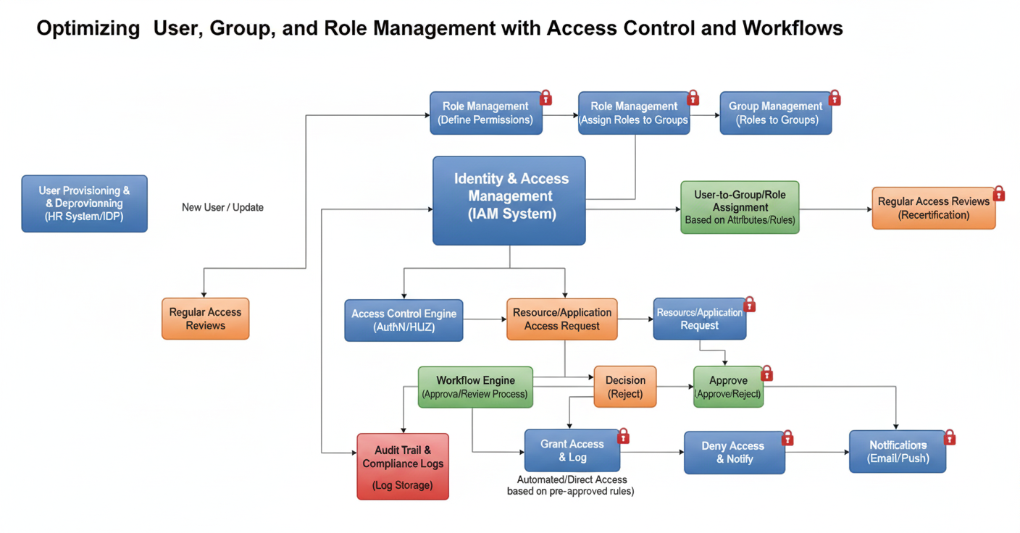
Figure 1: Architecture and Data Flow of User, Group, and Role Management System

Description of Data Flow:
- User/Administrator Request: A user initiates a request for new access or role modification.
- Validation Layer: System checks existing permissions, dependencies, and access policies.
- Workflow Engine: Request passes through multi-level approval workflows.
- Access Control Engine: After approval, permissions are applied or revoked dynamically.
- Audit & Logging: All events are recorded for compliance and monitoring.
- Notification: Alerts are sent to both requesters and administrators regarding status updates.

